MS SQL SERVER
Standard Operating Procedures
(SOP)
Change database owner of user database

Submitted to



By



CIS, Wipro Limited

Document Details

Project Name | Innogy SE
Account | CIS
IT Component/Application Title | Change database owner of user database.
Current Version | 1.2
List of Contributors | Pradipkumar Kansara, Kiran Bhalekar, Ayushi Gautam, Sivakumar Goud, Pramod Patil
Customer Contact Information

Version History
(All revisions made to this document must be listed in chronological order. All revisions must be approved. Review and Approval can be done by an internal source or by the customer)
Version | Date of Revision | Description | Author | Reviewed By | Approved By
1.0 | 03-12-2017 | Initial Draft | Sivakumar Goud | Pradipkumar Kansara | Santosh Badiger
1.1 | 05-12-2017 | Document Submitted. | Sivakumar Goud | Pradipkumar Kansara | Santosh Badiger
1.2 | 20-12-2018 | Updated the content | Pramod Patil | Pradipkumar Kansara | Santosh Badiger

Document Distribution List
Sr.No | Name and Company | Purpose
1 | RWEIT-SQLDBA | Document is helpful for day to day activities.

TABLE OF CONTENT
1. Purpose 4
2. Scope 4
3. Changing databse owner of user database ……………………………………………………………………..4
3.1 Database owner …………………………………………………………………………………………………4

3.2 Steps to change database owner ………………………………………………………………………5

3.2.1 Using SQL Server Management Studio ………………………………………………………….6

3.2.2 Changing database owner by using T-SQL script ………………………………………….7

3.2.3 Changing database owner by using Stored procedure ………………………………….7

4. Reference 7

1. Purpose

This document is prepared for the concept of Changing the database owner in SQL Server database administration services.

2. Scope
This document is prepared for SQL Wipro sustenance team and provides the concept of Changing the database owner SQL Server database.

3. Changing database owner of user database.

3.1 database owner

The database owner is a user that has permissions to perform all activities in a database. On a SQL server, database owners can be changed. Any user that has all the rights to connect to the SQL server can become the owner of any database.

3.2 Steps to change database owner

3.2.1. Using SQL Server Management Studio.

In the object explorer, right click on the database that you want to change the owner and go to “Properties” menu.
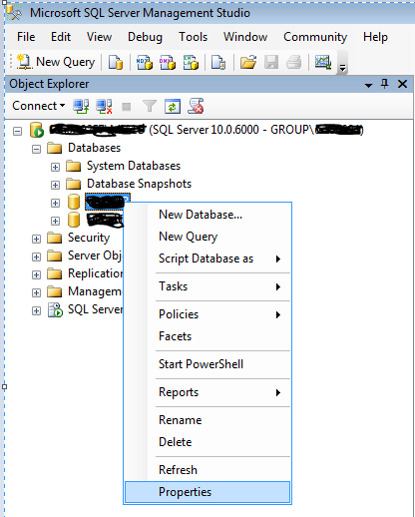

In the properties window, go to menu “Select a page -> Files”. Search or write the new owner. Once you’re done, click on OK to save your changes.

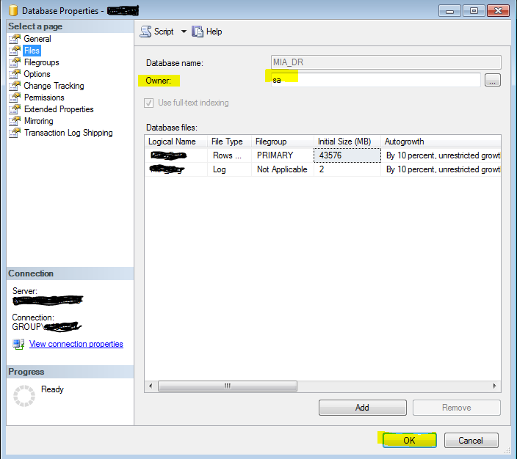

3.2.2 Changing database owner by using T-SQL script.

By using the below T-SQL script we can change database owner.

ALTER AUTHORIZATION ON DATABASE::[DATABASE NAME] TO [NEW OWNER];
GO

3.2.3 Changing database owner by using Stored procedure.

USE [Database name]
GO
EXEC dbo.sp_changedbowner @loginame = N'New owner'
GO

4 Reference
- https://blog.arvixe.com/change-database-owner-with-sql-server-management-studio/
- https://blog.sqlauthority.com/2017/04/09/change-owner-database-sql-server-interview-question-week-116/

